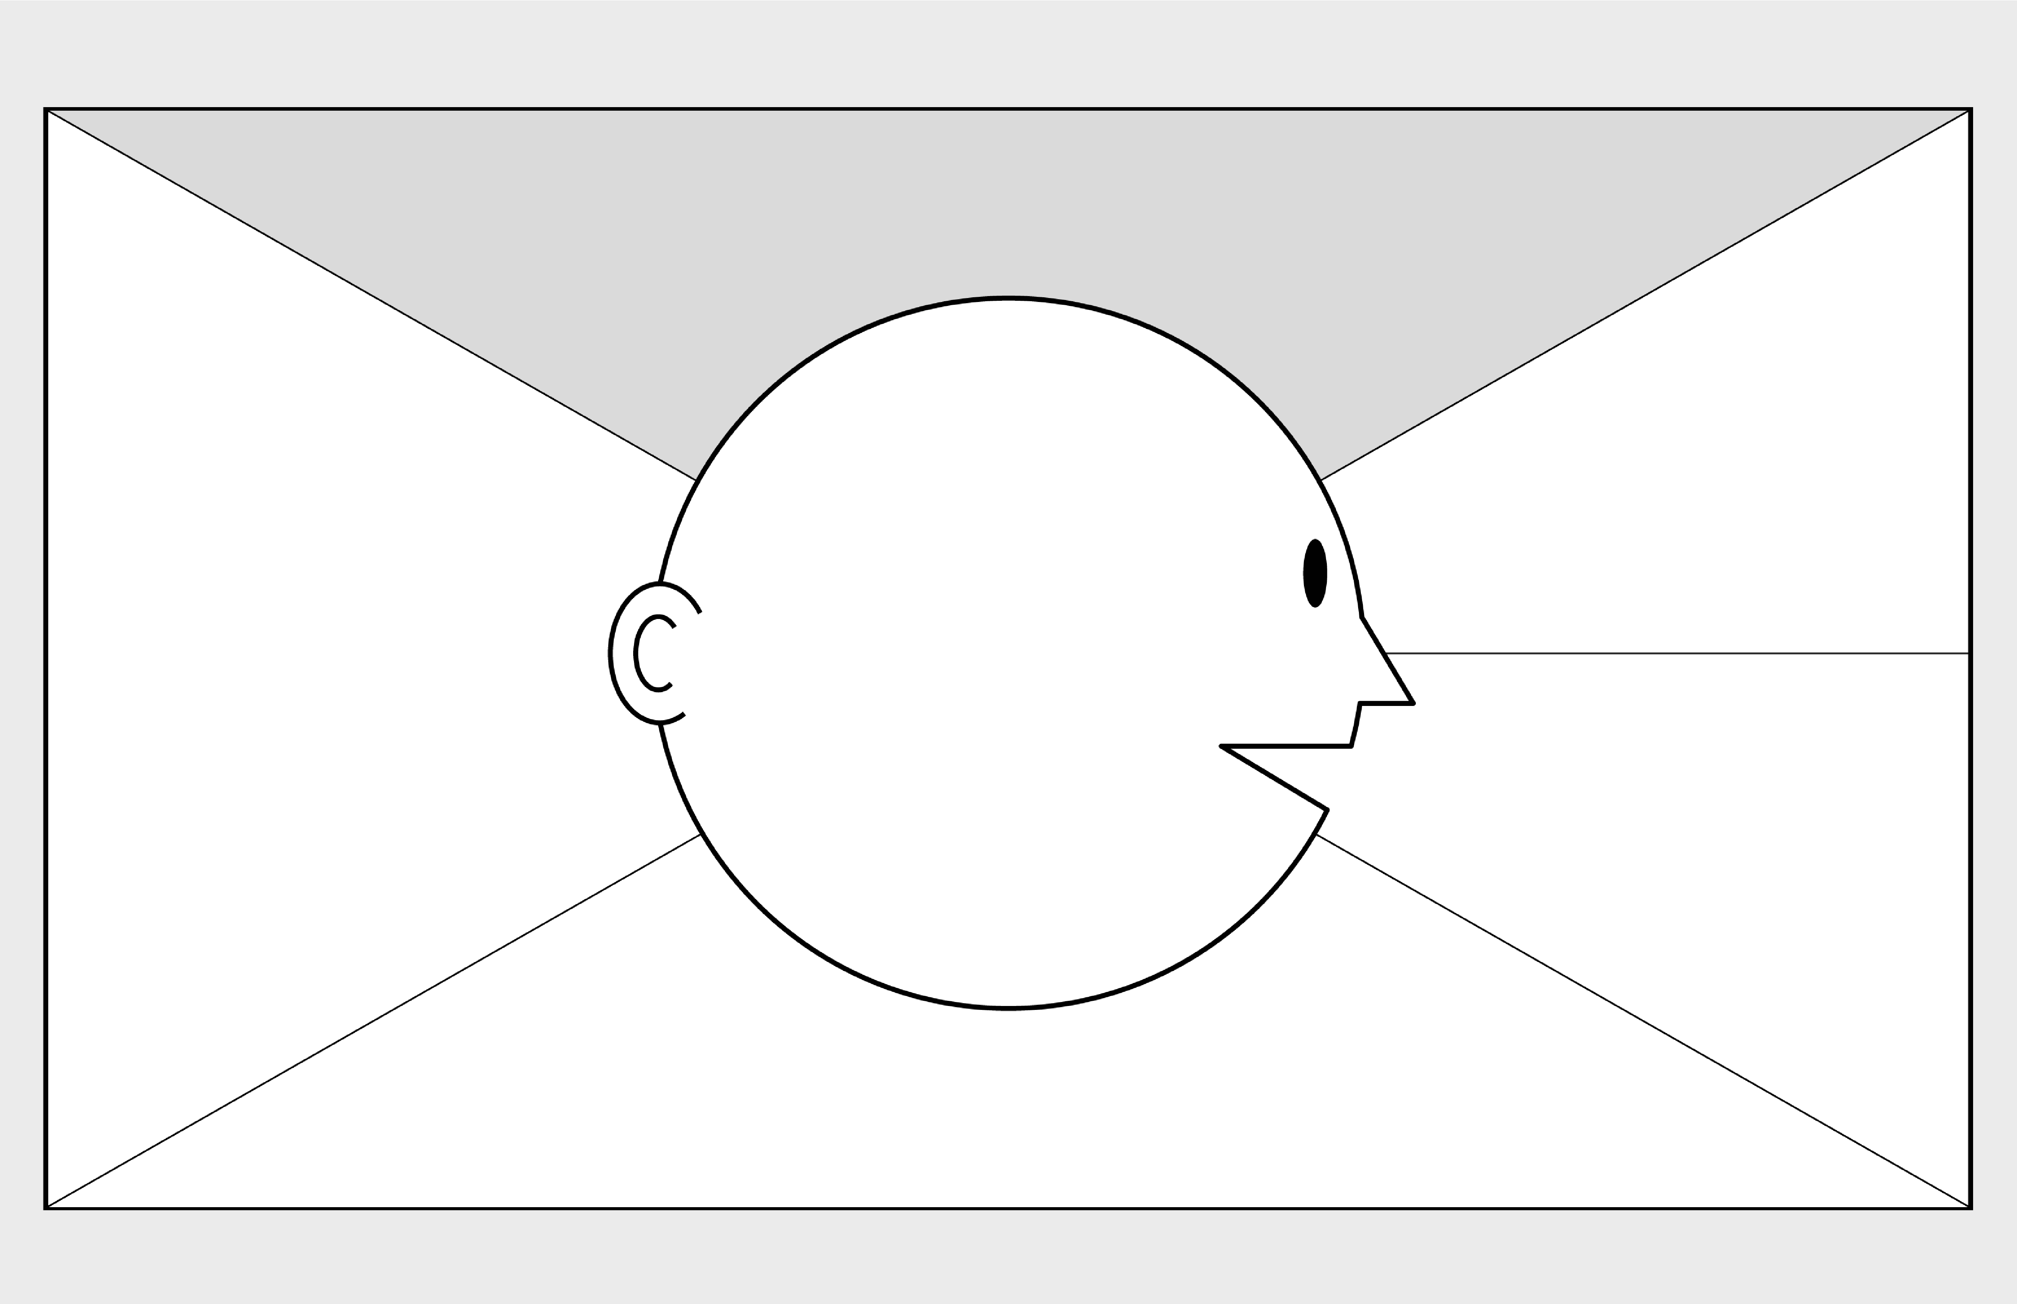

**Empathy Map Canvas**

*Designed for: Customers*

*Designed by: Khurshid Manal*

*Date:*

*Version:*

**WHO**

**are we empathizing with?**

**What do they need to DO**

**?**

What do they need to do differently?

What job(s) do they want or need to get done?

What decision(s) do they need to make?

How will we know they were successful?

Who is the person we want to understand?

What is the situation they are in?

What is their role in the situation?

**GOAL**

**What do they**

**SEE**

**?**

**What do they**

**SAY**

**?**

**What do they**

**DO**

**?**

**What do they**

**HEAR**

**?**

**What do they**

**THINK**

**and**

**FEEL**

**?**

What do they see in the marketplace?

What do they see in their immediate environment?

What do they see others saying and doing?

What are they watching and reading?

What have we heard them say?

What can we imagine them saying?

What do they do today?

What behavior have we observed?

What can we imagine them doing?

What are they hearing others say?

What are they hearing from friends?

What are they hearing from colleagues?

What are they hearing second

-

hand?

© 2017 Dave Gray, xplane.com

Last updated on 16 July 2017. Download a copy of this canvas at http://gamestorming.com/empathy

-

map/

**1**

**2**

**3**

**4**

**5**

**6**

**7**

**PAINS**

**GAINS**

What are their fears,

frustrations, and anxieties?

What are their wants,

needs, hopes and dreams?

What other thoughts and feelings might motivate their behavior?

Customers call when interested in a

product.

Customers hang up when spending too long in

the queue.

Customers who dislike getting calls from us stop returning.

Customers contact multiple other companies offering similar products to us.

“The RMs there are

all competent and friendly”

“You will be connected to someone

familiar with your chosen travel destination”

“You won’t spend a long time in the queue”

“Sometimes they call you and ask you if you’re interested in one of

their products which can be irritating”

Customers fear exorbitant prices and horrible experiences. Customers feel frustrated when made to wait for long periods of time in a queue.

Customers fear that the RM they contact will not be helpful and won’t provide any insight into their chosen travel destination. Customers are worried that the travel plans they constructed miss out on an interesting aspect of their destination

Customers want delicious food, unforgettable experiences, and relaxing accommodation at an affordable price.

Customers want to quickly speak with an RM that can inform them about their travel destination and provide an overview on activities to perform there without

wasting any time.